Skills & Employment Portal
User Guide

Participant Profile and Training Account Management

Version 1.0 – Release date: June 2023
Version | Date | Status | Comments
1.0 | June 2023 | New | Merger of pre-existing User Guides

For further information or assistance in using the Skills & Employment Portal, please contact the Skills SA Infoline on 1800 673 097 and ask to speak with the Contract Administration team.

Important Note: This is general information only. It does not in any way amend, vary or waive any Terms and Conditions of the Funded Activities Agreement (FAA). Where the content of this User Guide is inconsistent with the FAA or the Training Fee Framework or where an organisation is not clear on their responsibilities, they should seek appropriate independent advice.
Contents
1. Purpose 4
2. System login 4
3. Participant Search Overview 5
4. Allocate a Participant Number 6
5. View Participant History 8
6. Create a Participant Profile 9
7. Create a Training Account 11
7.1 Participant Details 12
7.2 Training Account Details 12
7.2.1 Funding Type / Program Name 12
7.2.2 Select a Course 13
7.2.3 Residency and Visa Details 13
7.2.4 Employment Service Provider Status 14
7.2.5 School Status 14
7.2.6 VSS Status 14
7.2.7 Concession Details 15
7.2.8 Prisoner Concession 15
7.2.9 Employment Details 16
7.2.10 Has Completed SACE or Equivalent 16
7.2.11 Education Details 17
7.2.12 Training Contract Details 17
7.3 Bridging Units 18
7.4 Course Fees and Training Information 19
7.4.1 Course Fees 19
7.4.2 Training Information 19
7.5 Complete the Creation of a Training Account 20
8. Training Account Search 22
9. Appendix 1 - Editable Training Account Fields 23
10. Completion of a Training Account – Issue of a Qualification 24
11. Leave from Enrolment 25
12. Closing a Training Account 26
13. Training Account Reports 27
14. Support and Assistance 30

1. Purpose
The Skills & Employment Portal (Portal) allows RTOs to create Participant Profiles, create and maintain Training Accounts for related subsidised training activity, and view claims and payment history. This User Guide helps users understand how to manage Participant Profiles and Training Accounts.
As per the current contracting requirements in the Funded Activities Agreement (FAA), RTOs must ensure that Participants and Training Accounts information in the Portal is accurate and up-to-date.
This document should be read in conjunction with your current FAA (and relevant STL Qualifications annexure) and the South Australian Vocational Education and Training – Training Fee Framework

2. System login
The Portal operates in a secure environment and requires a login. If you do not have a login, please complete the Access Request Form on our website.
On receipt of your Username and Password, use the following steps to access the Portal:
- Open your web browser. Please note that Microsoft Edge is our preferred internet platform.
- Go to https://Portal.statedevelopment.sa.gov.au/workready
- Select the ‘Sign in’ button in the top right-hand corner on the displayed Portal screen.
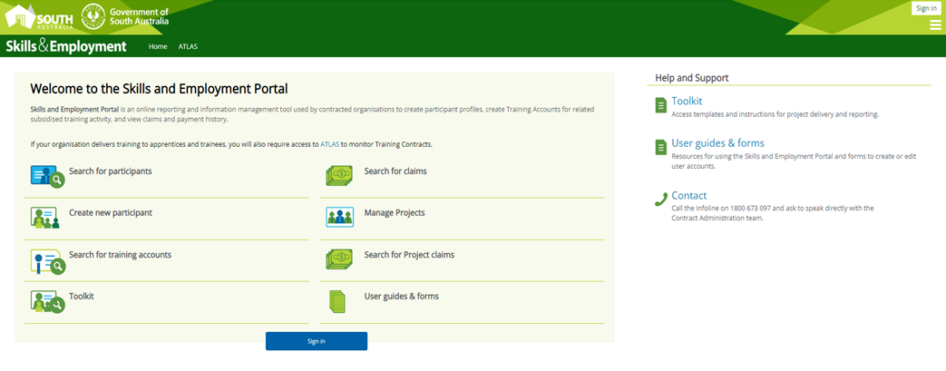
Figure 1 - Screenshot of the Skills and Employment Portal homepage
- Enter your Username (your email address) and Password.
- Click on the ‘Sign In’ button.
Note: You can amend your registered personal details against your Portal username. However, your username is your email address, so if you change your email address, you will need to de-activate your account and establish a new username for Portal access. If you change organisations, you will be required to de-activate your account and establish a new username for the Portal access.

3. Participant Search Overview
RTO searches for Participant
Participant Profile Exists?
Create Participant Profile, Allocate Participant Number
Yes
No
Check Participant Training History
Training Account Exists?
Create Training Account
Yes
No
Edit Training Account

Figure 2 - Workflow of Skills and Employment Portal search.

4. Allocate a Participant Number
The Participant number is a unique number generated by the Portal and is required for a Participant to access Government subsidised training. It is only allocated once and is used to record the delivery of accredited training. It may also be used to determine future eligibility for subsidised courses.
Note: The first step before allocating a Participant number is to search in the Portal to ensure that there is not an existing Participant Profile for the Participant.
From the Portal Menu Bar, select ‘Participant’ > ‘Participant Search’ from the sub-menu, as shown below:
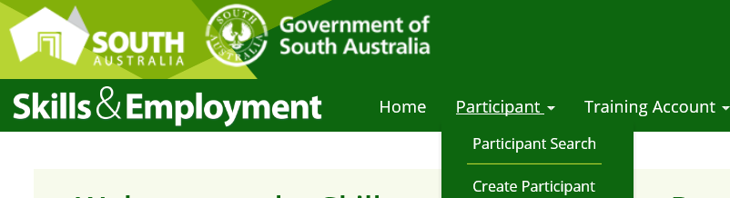
Figure 3 - Screenshot of Skills and Employment Portal - Participant menu

- You may search an existing Participant Profile in the Portal by entering either:
  - a combination of Participant details: First Name, Last Name and Date of Birth or
  - a Participant Number – this is a unique number generated by the Portal for a participant who has an existing profile.

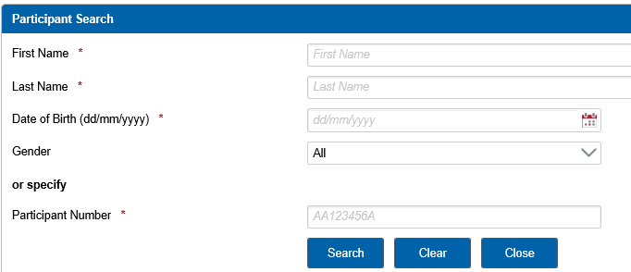
Figure 4 - Screenshot of Skills and Employment Portal - Participant Search

- If there is a match, the Participant record will appear as displayed below. If more than one Participant Profile is found, the Portal will prompt for more information about the Participant.
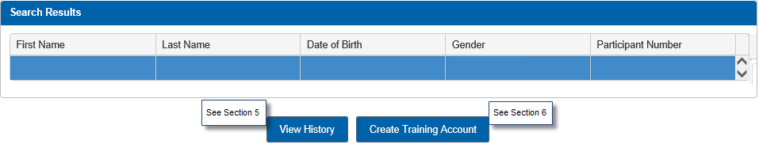
Figure 5 - Screenshot of Skills and Employment Portal - Search results
Note: Once you have retrieved a Participant Profile in the Portal, you should check the Participant’s history to ensure the Participant is eligible. To do this, simply click the ‘View History’ button.
If the Skills & Employment Portal is unable to retrieve matching data, a message will be displayed stating no Participant Profile could be found. You can proceed to Section 6 - Create a Participant Profile.

5. View Participant History
The Participant History Screen provides further information on Training Account(s) created against a participant. These Training Accounts may or may not impact on the participant’s entitlement, as explained below.
Training Accounts which show under the ‘Subsidised Training History’ section may impact on entitlement, include:
- Training Accounts that are defined as ‘Active’ (i.e. those that have a status of ‘Active No Activity’, ‘Active with Activity’ or ‘Leave from Enrolment’) or
- Training Accounts that have a ‘Qualification Issued’ status and the Training Account End Date is after 01/10/2015.
Training Accounts which show under the ‘Subsidised Training History (no impact on Entitlement)’ section include:
- Training Accounts that have a ‘Qualification Issued’ status and the Training Account End Date is prior to the 01/10/2015 or
- Training Accounts that have a ‘Closed’ status.
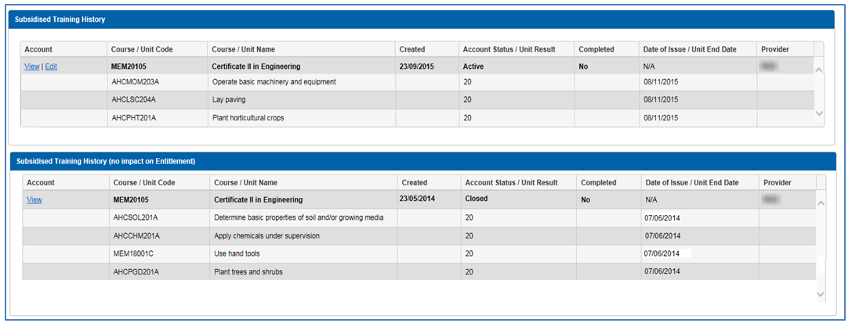
Figure 6 - Screenshot of Skills and Employment Portal - Subsidised Training History
From the above display, you can see the date when Training Accounts were created, status of the Training Accounts and the date of ‘Qualification Issued’ (if any). For Training Accounts where you are the RTO, an option to view further details will appear under the ‘Account’ column. Click ‘View’ to ‘Open/Edit’ the Training Account.
Note: As soon as a Training Account is created, the course information will show on the Participant History, even before any units have been claimed.

6. Create a Participant Profile
Participant Profiles should only be created if one does not already exist for that participant. Before creating a Participant Profile, you must first search the Portal to check if a Profile already exists to avoid the creation of duplicate records.
Creation of a Participant Profile can be actioned via the Menu Bar by selecting Participant > Create Participant from the sub-menu as shown below, by using information you have gathered on your Enrolment Form.
Figure 7 - Screenshot of Skills and Employment Portal - Participant Menu
Refer to the table below for information to be entered into the Portal. Mandatory fields are indicated by an asterisk (*). Please check information entered for accuracy before completing the Participant Profile and ensure information is consistent with any training reported in STELA for that participant.
Field | Format | Additional Information
Participant Details
First Name * | Free text | This field is mandatory. Use capitals for first letter of each name unless this is not a required in the spelling of the name.
Preferred First Name | Free text | Use capitals for first letter of each name unless this is not a required in the spelling of the name.
Middle Name | Free text | Used to search if there is more than one match in the Participant Profile.  Use capitals for first letter of each name unless this is not a required in the spelling of the name.
Last Name * | Free text | This field is mandatory. Use capitals for the first letter of the last name unless this is not required in the spelling of the name.
Gender * | Drop down selection | This field is mandatory. Options are: Male, Female, or Not specified
Date of Birth * | Number only | This field is mandatory. Date format – DD/MM/YYYY
Residential Address Details
Address Line 1 | Free Text | Unit, Road, Street, Avenue etc.
Address Line 2 | Free Text | Unit, Road, Street, Avenue etc.
Postcode * | Number only | This field is mandatory. Example: 5000
Suburb * | Drop down selection | This field is mandatory. Suburb options will display upon entry of a valid postcode. Select the appropriate suburb name.
Contact Details
Email * | Free Text | Must provide at least an email address OR mobile phone number.  Example: email@address.com.au
Mobile Phone Number * | Number only | Must provide at least an email address OR mobile phone number.  Please do not use spaces. Example: 0444144144
Home Phone Number | Number only | Please do not use spaces. Example: 0818881888
Work Phone Number | Number only | Please do not use spaces. Example: 0818881888
Participant Agreement
Participant consent has been gained * | Check box | This field is mandatory. Checking this box is an indication that the Participant has completed and signed a Participant Agreement form for collection and use of their personal information*.
* Note that the Participant Agreement form sets out the purpose for which personal information is collected by the Minister for Education, Training and Skills and how it will be used. The FAA requires RTOs to enter into a Participant Agreement once for each participant. RTOs are not required to email a copy of the completed Participant Agreement form to the Department however they must retain the signed form.
For participants that have only one legal name (without first or last name), that name should be used to populate both the participant’s Last Name and First Name fields. This is consistent with the naming convention as required in AVETMISS: Fact Sheet – Reporting Client Names.pdf (ncver.edu.au).

Complete the process to create a Participant Profile by selecting ‘Create Participant’.

Note: Once the Participant Profile has been created, you are unable to amend any of its details. Any amendments to the Participant Profile should be requested in writing by email to SkillsContracts@sa.gov.au together with supporting evidence.
To create a Training Account from this screen, select ‘Create Training Account’, as below:
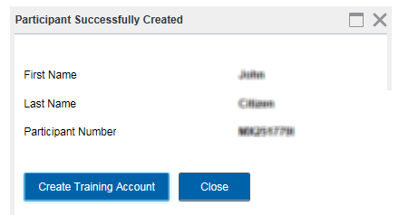
Figure 8 - Screenshot of Skills and Employment Portal - Participant Successfully Created

7. Create a Training Account
NOTE: The Minister’s liability to pay the subsidy will only be triggered if a Participant Profile and Training Account are created in the Skills and Employment Portal. If you experience any trouble in creating a Participant Profile or Training Account, please contact the Contract Administration team for assistance.
To create a Training Account for an established Participant Profile, you must first complete a ‘Participant Search’, as details in Section 4 above.
Figure 9 - Screenshot of Skills and Employment Portal - Participant Menu

Enter the Participant Details or Participant Number and select ‘Search’. If a Participant Profile has been established, the Participants Profile will be displayed as below:
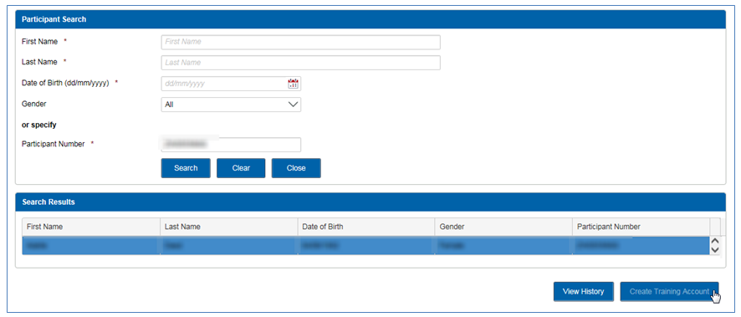
Figure 10 - Screenshot of Skills and Employment Portal - Participant Search
Note: Prior to creating a Training Account, you must:
- check the Participant History to confirm entitlement
- check to see that the Participant Profile data matches the participant’s enrolment, and then select the ‘Create Training Account’ button to create a Training Account for the selected Participant
- ensure to enter correct details when creating a Training Account, as data inaccuracy may impact on payment.

7.1 Participant Details
On clicking the ‘Create Training Account’ button, the following screen will appear:
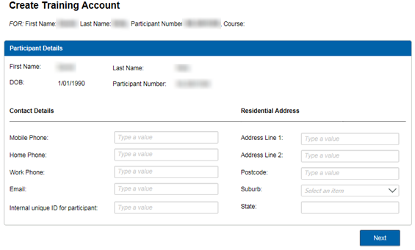
Figure 11 - Screenshot of Skills and Employment Portal - Participant Details
Internal unique ID: Often referred to as RTO Student ID, this is the most important link between your Training Account and AVETMISS data. This number is assigned to the Participant, either from your Student Management Software or if you use STELA as an enrolment system, the State Student ID Number from STELA.
This field is mandatory and is used to match your AVETMISS data to the Training Account. Failing this, the claim will not transition to the payment system for further assessment.
Note: If you are not the RTO who originally created the Participant Profile, you will be required to enter the residential address and contact details of the participant, in the Training Account.

7.2 Training Account Details

7.2.1 Funding Type / Program Name
This is a drop-down selection. A correct Program Name must be selected as this determines which courses will be displayed for selection in the next step. The Program Name should be indicated on the relevant contracting documentation in your FAA, but if you are unsure, please contact the Contract Administration team for assistance.
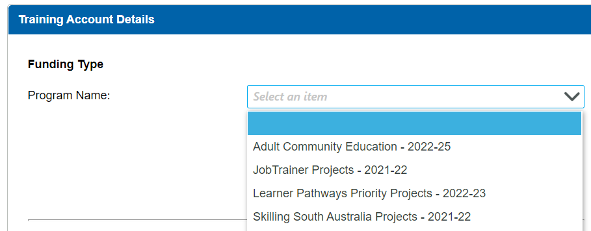
Figure 12 - Screenshot of Skills and Employment Portal – Select Program Name

7.2.2 Select a Course
A selection of Courses will be displayed if they are available on your contracted scope for the ‘Program Name’ that was selected in the previous step.
Click Select a Course, then enter either the National Code or Course Name, double click on the National Code / Course Name to add to the Training Account.
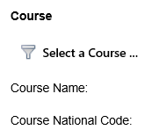 | 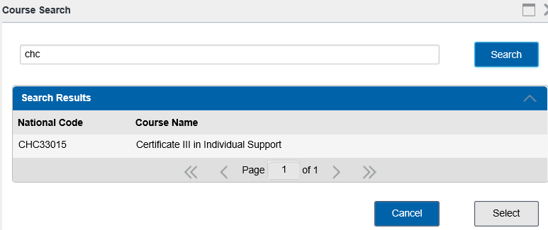
Figure 13 - Screenshot of Skills and Employment Portal - Select a Course

7.2.3 Residency and Visa Details
Select the relevant Residency Type. If the Participant’s Residency Type is a ‘Holder of eligible visa’, a Visa Category Name (subclass) must be selected.
If a Visa Subclass is not listed, an RTO may apply for an exemption to the eligibility criteria. Complete an ‘Application for Funded Training Exemption - Special circumstances’ and email to SkillsContracts@sa.gov.au for consideration. All applications are assessed on a case-by-case basis.
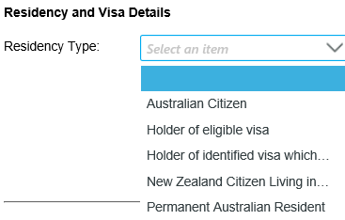 | 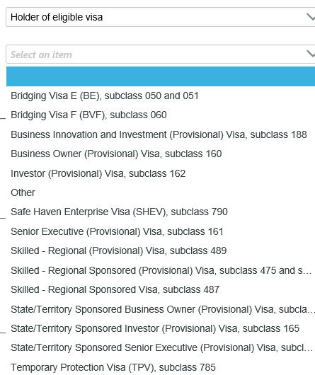
Figure 14 - Screenshot of Skills and Employment Portal - Residency and Visa Details

7.2.4 Employment Service Provider Status
Select ‘Yes’ or ‘No’ depending on whether the Participant is registered with an Employment Service Provider. If ‘Yes’ is selected, it is compulsory to enter the Employment Service Provider and the Participants Job Seeker ID Number.
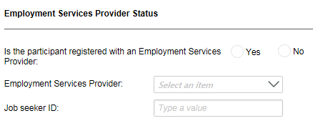
Figure 15 - Screenshot of Skills and Employment Portal - Employment Service Provider Status

7.2.5 School Status
Select ‘Yes’ or ‘No’ depending on whether the Participant is enrolled at school:
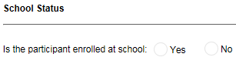
Figure 16 - Screenshot of Skills and Employment Portal - School Status

7.2.6 VSS Status
Select ‘Yes’ or ‘No’ depending on whether the Participant is a VET for School Student:
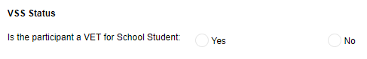
Figure 17 - Screenshot of Skills and Employment Portal – VET for School student

7.2.7 Concession Details
Holders of a Commonwealth Government Concession Card are eligible for concession for the whole duration of their Training Account. Select a relevant Commonwealth Government Concession Card.
An ‘Active Training Accounts with Concession’ report is available to assist.
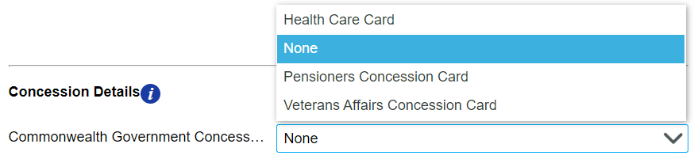
Figure 18 - Screenshot of Skills and Employment Portal - Concession Details

7.2.8 Prisoner Concession
As per the Training Fee Framework, prisoners in a South Australian correctional institution are eligible for concession.
The ‘Concession for Prisoner’ field is not visible. Please go ahead with creating a Training Account for an eligible prisoner as usual and email the Contract Administration team at SkillsContracts@sa.gov.au once the Training Account has been created to have the concession detail amended on your behalf.
Figure 19 - Screenshot of Skills and Employment Portal - Concession for Prisoner

7.2.9 Employment Details
Select ‘Yes’ or ‘No’ depending on whether the Participant is employed or not. Further details of ‘Place of Work Address’ are required if ‘Yes’ is selected.
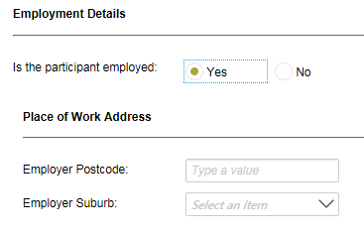
Figure 20 - Screenshot of Skills and Employment Portal - Employment Details

7.2.10 Has Completed SACE or Equivalent
Select ‘Yes’ or ‘No’ depending on whether the Participant has completed SACE/Year 12 or equivalent.
Note: This information is essential to assess eligibility and course entitlement against the new criteria and should be collected for all Participants. Collection of a Participant’s highest level of schooling is also mandatory data for AVETMISS reporting.
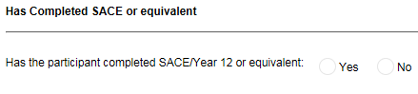
Figure 21 - Screenshot of Skills and Employment Portal – Completion of SACE or equivalent

7.2.11 Education Details
Select the ‘Highest level of education’ the Participant has previously achieved in Australia.
Note: Only AQTF Recognised and higher Educational Recognised Qualifications should be listed in this section. Overseas Qualifications are not recognised in Australia and should not be listed.
 | 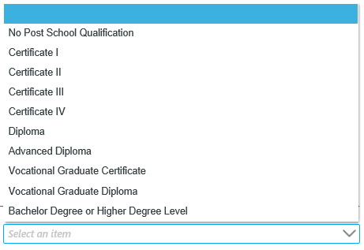
Figure 22 - Screenshot of Skills and Employment Portal - Education Details

7.2.12 Training Contract Details
Select if the Participant has an approved Training Contract. Note: If the Course Condition is ‘Training Contract Only’, this section must be completed and the Training Contract number be entered accurately for payment assessment. If a Training Account is created and the valid Training Contract number is not provided, an RTO accepts the risk that no subsidies will be paid.
Select if the Training Contract is a School Based Training Contract and enter the Training Contract number. The number must be accurate and in this format: 123456\1
Note: If the Participant is an approved Skilled Migrant, please select ‘Approved Training Contract – YES’, then enter the Exemption Number in the ‘Training Contract Number’ field.
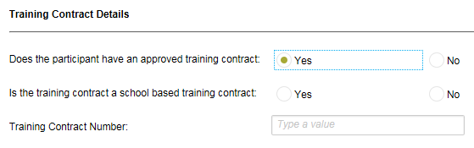
Figure 23 - Screenshot of Skills and Employment Portal - Training Contract details

7.3 Bridging Units
Once the desired Course Code has been selected, you may select up to five Bridging Units to be attached to the course.
Select ‘Add Bridging Unit’ to continue or ‘Next’ to skip adding bridging units.
Note: An eligible participant is entitled to undertake up to five bridging units as part of a course. An Upfront Assessment of Need must have been completed to determine additional requirements. Refer to the ‘Upfront Assessment of Need Guidelines’ or your FAA for further information.
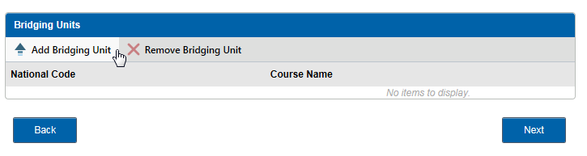
Figure 24 - Screenshot of Skills and Employment Portal - Bridging Units
Enter the Bridging Name/Code or click ‘Search’ to retrieve all units. Select which units are to be attached.
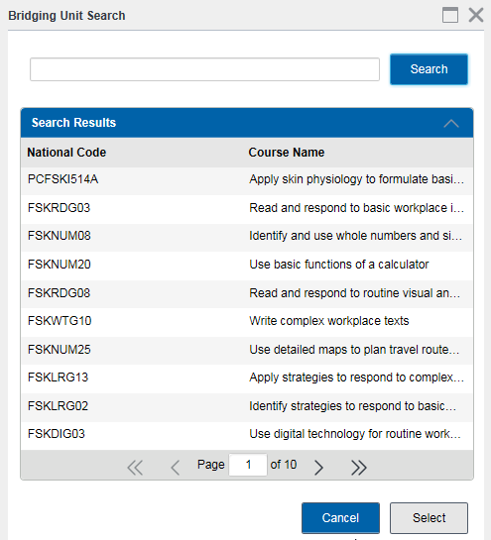
Figure 25 - Screenshot of Skills and Employment Portal - Bridging Unit Search
Once units have been attached, all added units will be shown in the right column. If a unit has been added incorrectly, highlight the unit and select ‘Remove Bridging Unit’. Once all bridging units are attached select ‘Next’ to continue or leave blank if not applicable.
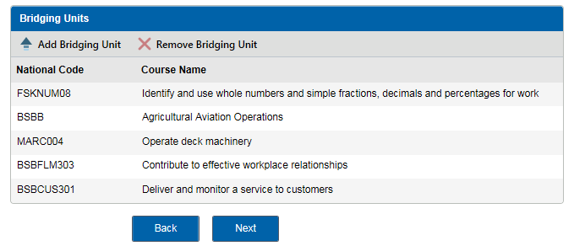
Figure 26 - Screenshot of Skills and Employment Portal - Bridging Units
Note: Units are to be added individually. Bridging units may be added at any time while the Training Account is active, using the ‘Edit Training Account’ function. The Unit must be added to the Training Account prior to the training commencement date of the Unit of Competency. Bridging units cannot be removed from a Training Account once a subsidy has been paid. Bridging Units are not eligible for school-based Participants, unless previously approved.

7.4 Course Fees and Training Information

7.4.1 Course Fees
The ‘Course Fee for this participant (before any concessions)’ field refers to the total subsidised course fee that you estimate the participant will be charged, before any concession reimbursements.
Note: This is NOT your Fee for Service (Full Fee). This field refers to an estimated course fee charged for the Participant, taking into account bridging units, electives, Recognised Prior Learning (RPL) or Credit Transfer (CT). If the Participant is eligible for concession, this should not include the concession reimbursement that you expect to receive. Refer to the Training Fee Framework for information on how a concession reimbursement is calculated.

7.4.2 Training Information
Enter the ‘Training Commencement Date’ and the ‘Training Expected to Finish Date’.
Note: These two dates are mandatory but editable.
Enter the ‘Responsible delivery workgroup’. Leave ‘blank’ if not applicable.
Enter the ‘Suburb’ and ‘Postcode’ of the delivery location. Note: These fields are mandatory as the subsidy is calculated based on delivery location. Where training delivery may take place in a variety of locations, enter the predominant delivery location.
Select if the Participant is going to be provided with ‘Learner Case Management’.
Select if the Participant has applied for ‘VET Student Loans’.

Select ‘Next’ to continue.
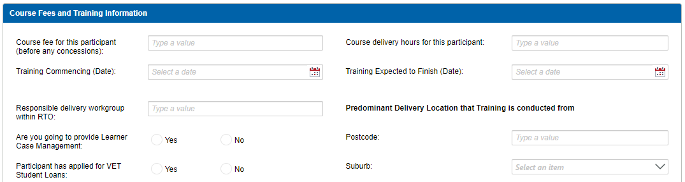
Figure 27 - Screenshot of Skills and Employment Portal - Course Fees and Training Information

7.5 Complete the Creation of a Training Account
Review the ‘Training Account Summary’ screen to ensure all details entered are correct.
Confirm that the ‘Participant has made the declaration that information provided at enrolment is to their best knowledge true and correct’. Select ‘Submit’ to complete the process.
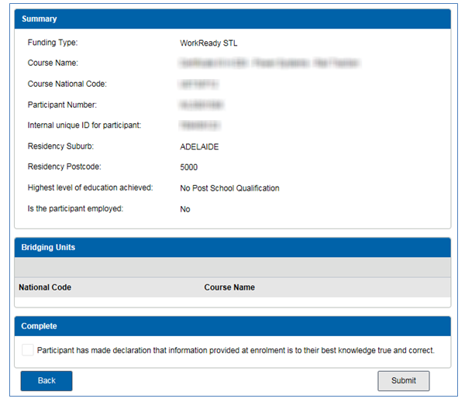
Figure 28 - Screenshot of Skills and Employment Portal - Summary and Confirmation
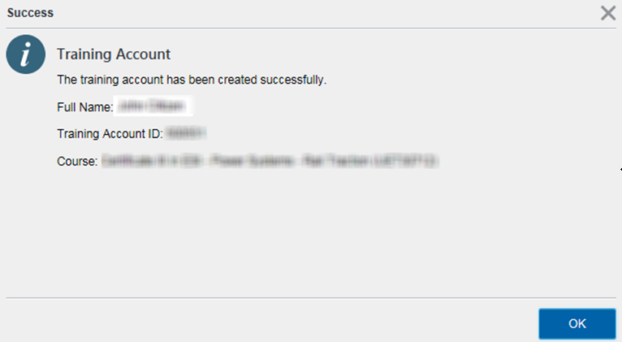
Figure 29 - Screenshot of Skills and Employment Portal - Successful Training Account creation
Congratulations - You have successfully created a Participant’s Training Account.
At this point, if the criteria for creating a Training Account have not been met, an error message will appear, and you will have the opportunity to go ‘Back’ through the screens to review and amend. If you require any assistance when receiving an error message, please contact the Contract Administration team.

8. Training Account Search
Training Account Search can be done via the Menu Bar. Select ‘Training Account’, then ‘Training Account Search’ from the sub menu, as shown below:

Figure 30 - Screenshot of Skills and Employment Portal - Training Account menu
To search for a Training Account, you may input one or any of the following details, until a match is found, e.g.:
- The full First Name and Last Name
- Internal unique ID (this should be known by the RTO)
- Participant Number
- Course Code
- Course Name.
Alternatively, you can retrieve a list of all Training Accounts for your organisation by selecting ‘Search’.
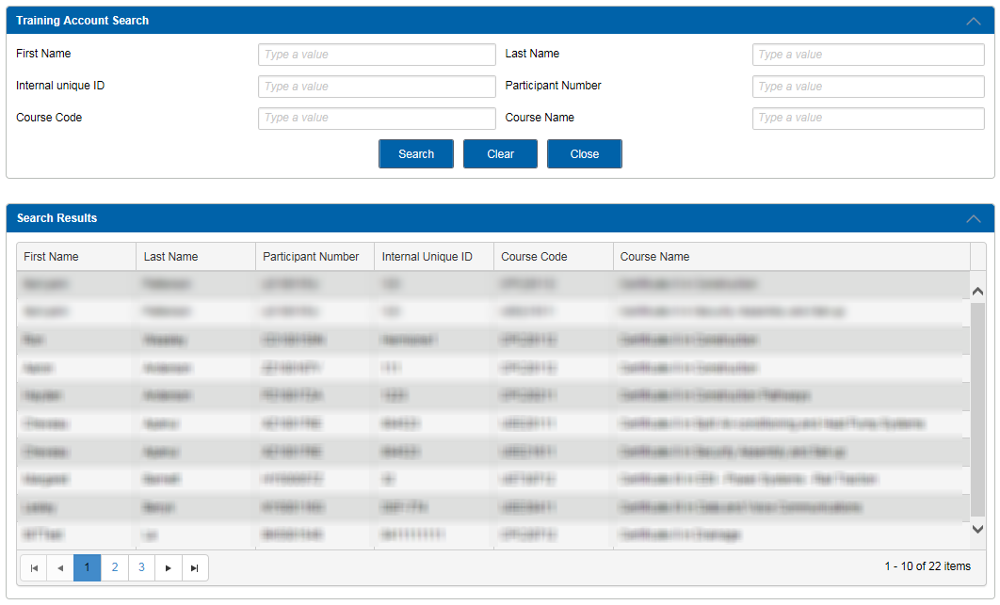
Figure 31 - Screenshot of Skills and Employment Portal - Training Account Search
A Participant may have multiple Training Accounts. Select ‘View’ or ‘Edit’ for full details of a Training Account. Note: Training Accounts cannot be created from this section of the Portal. Instead, this needs to be done via the Participant Search menu, see Section 7 above for details.
Select ‘Edit’ to update information in editable fields for that Training Account - see Section 9 - Appendix 1.

9. Appendix 1 - Editable Training Account Fields
The following fields are able to be edited once a Training Account is created and remains Active:
- Commonwealth Government Concession Card type
- Training Commencing and Expected to Finish Dates
- Internal unique ID
- Workgroup
- Applied for VET Student Loans
- Delivery Suburb
- Delivery Postcode
- Leave from Enrolment Start and End Dates.

10. Completion of a Training Account – Issue of a Qualification
When a participant has completed a qualification, RTOs need to record the issue of the qualification in both their own Student Enrolment System (or STELA) and the Portal.
To update the Training Account with ‘Qualification Issued’:
- Follow the ‘Edit Training Account’ direction in Section 4
- Scroll down to the bottom of the Training Account to the Summary Information field
- From the ‘Training Account Status’ drop-down box, select ‘Qualification Issued’ (as illustrated below), enter the Parchment Number and the Parchment Issued Date. These fields need to match the parchment details that you have entered in your Student Enrolment System (or STELA).

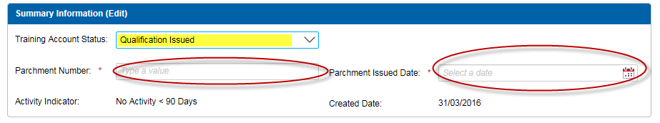
Figure 32 - Screenshot of the Skills and Employment Portal – Edit Training Account - Qualification Issued
Note:
- This process will trigger a Completion Payment, where eligible.
- The date that the parchment details are entered in the Training Account is the Training Account End Date, therefore all training needs to have been completed.
- The Parchment Issued Date is not the Training Account End Date.
- ‘Skill Set’ Training Accounts – to be updated with ‘Qualification Issued’ status once completed. Note that if a Parchment Number is not available, a Statement of Attainment number is acceptable for Skill Set Training Account.
- ‘ESTC’ Training Accounts – refer to Section 12 - Closing a Training Account.

11. Leave from Enrolment
This status is to accommodate participants who wish to suspend their Training Account and recommence the training at a later date. To enter the ‘Leave from Enrolment’ Start and End Dates:
- Follow the ‘Edit Training Account’ direction in Section 8
- Scroll down to the bottom of the Training Account to the Summary Information field
- Select ‘Leave from Enrolment’. The additional fields for Leave Start and End Dates will appear for you to complete.
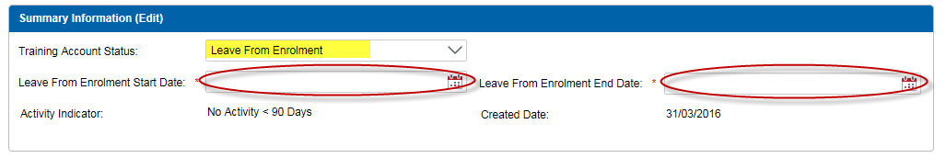
Figure 33 - Screenshot of the Skills and Employment Portal – Edit Training Account – Leave from Enrolment
* See Section 13 on How to run a Report on ‘Training Accounts with ‘Leave from Enrolment’ status’ into Excel. RTOs should use this report to monitor all Training Accounts with ‘Leave from Enrolment’ status and keep the Training Account updated with accurate information.

12. Closing a Training Account
RTOs must maintain Training Accounts accurately and ‘Close’ them when participants do not commence training or withdraw from their course.
The example below shows that this Training Account’s current status is ‘Active’ however ‘No Activity => 90 days’. This indicates that the Training Account needs to be closed if no activity is envisaged.
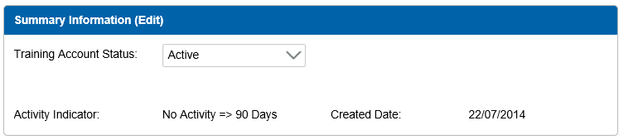
Figure 34 - Screenshot of the Skills and Employment Portal – Edit Training Account - Active No Activity
‘ESTC’ Training Accounts must be ‘Closed’ not ‘Qualification Issued’ to avoid eligibility issues for the student.
To close a Training Account:
- Follow the ‘Edit Training Account’ direction in Section 8
- Scroll down to the bottom of the Training Account to the Summary Information field, select the status ‘Closed’ and provide a reason for the closure. Examples may include:
  - Ceased training services; or
  - No longer enrolled in the course; or
  - [For ‘ESTC’ Training Accounts only] Student completed the Skill Cluster.
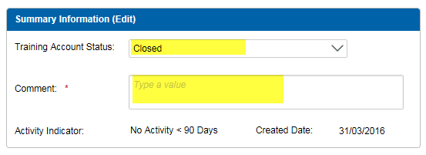
Figure 35 - Screenshot of the Skills and Employment Portal – Closure of a Training Account
* See Section 13 on How to run a Report on ‘Active Training Accounts with No Activity’ into Excel. RTOs should use this report to monitor all ‘Active Training Accounts with No Activity’ for more than 90 days and close them where required.

13. Training Account Reports
The following ‘Training Account’ reports are available for download at any time into Excel to provide an up-to-date summary on:
- All Data - Training Accounts report
- Active Training Accounts with Concession
- Active Training Accounts with No Activity*
- Training Accounts with status ‘Leave from Enrolment’ and
- Training Accounts with Bridging Units.
Note: The ‘Active Training Accounts with No Activity’ report includes all Training Accounts that are Active and have no activity, or had no payments made for more than 90 days, since the Training Account Creation Date or the Last Activity Date, whichever occurs later. This means if you have created a Training Account and expected to commence training more than 90 days after the Training Account creation date, this Training Account will also appear in this report. Expected Training Start and End Dates are included for this purpose.
Data for these reports is refreshed hourly, so if Training Account data is being edited, a new report will be able to be prepared on the same day to confirm the changes.
Training Account Reports can be accessed by selecting ‘Training Account’ - Training Account Reports’ from the sub menu, as shown below:


Figure 36 - Screenshot of the Skills and Employment Portal - Training Account Reports menu

The search screen overleaf will be displayed. Reports are generated by selecting one of the five reports from the drop-down menu option.
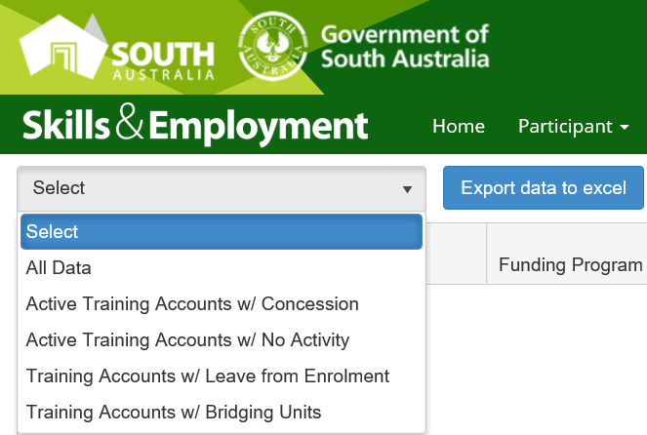
Figure 37 - Screenshot of the Skills and Employment Portal - Training Account Report types
Should the report not contain any data, a message will appear to confirm “No data is available for export”
Exporting the data is actioned by selecting the desired report from the drop-down list, then the ‘Export data to excel’ button.
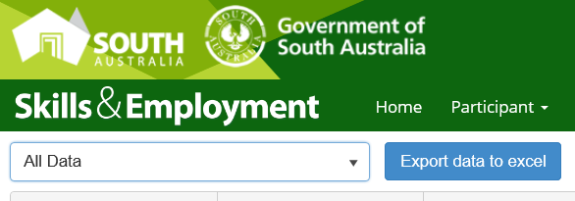
Figure 38 - Screenshot of Skills and Employment Portal - Training Account Report Export function
Once you have selected the button, the system will begin the process of downloading the report:
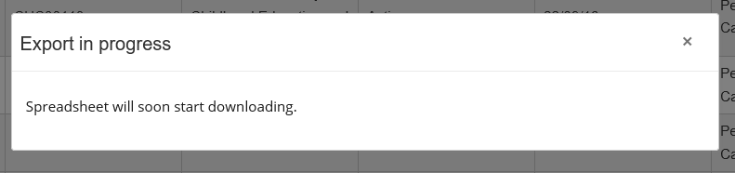
Figure 39 - Screenshot of Skills and Employment Portal - Training Account Report - Export in progress

The system will present you with an option to either open or save the file:
Figure 40 - Screenshot of Skills and Employment Portal - Training Account Report – Open or Save file
If you have selected the open function, the Training Account Report will be exported and opened in Excel as displayed below:
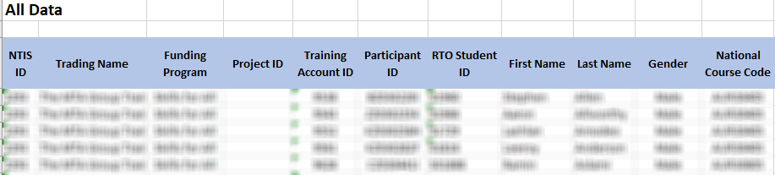
Figure 41 - Screenshot of Skills and Employment Portal - Training Account Report - Export in Excel

14. Support and Assistance
If you experience trouble creating a Participant Profile or Training Account or require any assistance with using the Skills & Employment Portal, please do not hesitate to contact the Contract Administration team.
Your feedback and comments are welcome so that we can continuously improve the Portal to meet the needs of our clients.
Telephone: 1800 673 097 and ask for the Contract Administration team
Email: SkillsContracts@sa.gov.au

